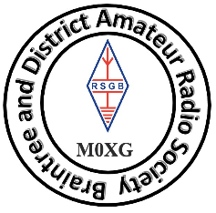**Braintree & District Amateur Radio Society**

**Membership Application/Renewal**

**2024/2025**

Name (Block Capitals): ______________________________________ Call Sign: ________________

Address: ____________________________________________________________________________

Post Code: ____________________ Telephone Number: ______________________________

Email: _________________________________________ Use to circulate BARSCOM by Email (Y) / (N)

(Please print Email address for Clarity)

Email used for general club circulars (Y) / (N)

I hereby consent to my personal data being held by the club to provide all the benefits of membership by the designated officers of Braintree and District Amateur Radio Society in accordance with the Society’s Data Protection Policy.

I also understand that I may cancel my consent for the society to use my personal data at any time by sending an email to the Data Protection Officer of Braintree and District Amateur Radio Society (treasurer@badars.co.uk) with UNSUBSCRIBE in the subject line.

Signed: ____________________________________________ Date: ____________________

**MEMBERSHIP FEE FOR 2023/2024**

Age: Under 18 (£12.00) [ ] Adult (£18.00) [ ] 65 & over (£12.00) [ ]

BZ is a club repeat in need of support, would you like to contribute a donation towards BZ: £ .

**Total £ .**

**The club can no longer accepted cheques**, we take cash, bank transfer (details on request) or card payment on club nights.

Please complete and send this form to:

Club Treasurer

Mr Colin Johnson

22 Carleton Close

Great Yeldham

Halstead

Essex

CO9 4QJ

Or hand to any committee member. Membership cards will be given out to all on receipt of this form and club membership fee.

On behalf of the committee, we would like to thanks you for your new or continuing membership.

Date Received: ____________________________ Card Issue Date: __________________

Treasurer’s signature: _______________________________

*Payment* Cash [ ] Card [ ] Bank Transfer [ ]